**MACHINE LEARNING BASED SPAM COMMENTS DETECTION ON YOUTUBE**

**ABSTRACT:**

The rise of spam comments on platforms like YouTube has become a significant concern, as they not only hinder genuine user engagement but also pose serious risks to users' safety and privacy. Machine Learning (ML) and Deep Learning (DL) offers a powerful solution to combat spam comments by automating the process of detecting and preventing them. With the ability to analyze vast amounts of data and patterns, ML algorithms can effectively distinguish between legitimate comments and those that are spam ML and DL algorithms calculates the likelihood of a comment being spam based on its characteristics and the occurrence of specific keywords or phrases that are typical of spam content. By training the algorithm on a labeled dataset of spam and non-spam comments, it can learn to recognize patterns and generalize its understanding to new, unseen comments. Achieving a detection accuracy of 92.78% is indeed promising, but researchers and developers continue to explore other ML techniques and combinations to further improve the accuracy and robustness of spam comment detection systems. Ensemble methods, deep learning, and natural language processing (NLP) techniques are among the advanced ML approaches gaining attention in this domain. One crucial aspect of an effective spam detection system is its adaptability and responsiveness to emerging spam tactics.

Keywords: ML evaluation, ML techniques , Spam detection, Deep learning.

**Introduction:**

Machine Learning (ML) has revolutionized various domains, and its application to online platforms is notably transforming content moderation. One such prominent arena is the detection of spam comments on YouTube. With the exponential growth of user-generated content, ensuring a safe and engaging environment for users has become a paramount concern. ML-based spam comments detection on YouTube leverages advanced algorithms to swiftly and accurately identify and filter out undesirable and misleading comments. This innovative approach harnesses the power of ML to automatically learn patterns and characteristics of spam comments from vast datasets. By analyzing linguistic cues, syntactical irregularities, and user engagement metrics, ML models can distinguish between genuine and spam comments. These models are trained on diverse samples of comments, enabling them to adapt and evolve alongside evolving spam tactics. The impact of ML-based spam comments detection is multifaceted. It not only safeguards the user experience by curbing the visibility of spam but also enhances the authenticity and credibility of discussions. By reducing the noise generated by spam, the quality of interactions among users is elevated, fostering meaningful conversations and community growth. While ML-based detection is an effective tool, continuous refinement and updates are essential to stay ahead of sophisticated spam techniques. Collaborative efforts between ML engineers and domain experts are crucial to fine-tune models, ensuring minimal false positives and negatives. As YouTube continues to evolve as a dynamic platform, Machine Learning plays a pivotal role in maintaining a vibrant, safe, and trustworthy online ecosystem.

**2. Related works:**

[1] Sah, U. K., & Parmar, N. (2017). An approach for Malicious Spam Detection in Email with comparison of different classifiers. In this paper, today one of the cheapest form of communication in the world is email, and its simplicity makes it vulnerable to many threats. One of the most important threats to email is spam; unsolicited email, especially when advertising agency send a mass mail. Spam email may also include malware as scripts or other executable file. Sometimes they also consist harmful attachments or links to phishing websites. This malicious spam threatens the privacy and security of large amount of sensitive data. Hence, a system that can automatically learn how to classify malicious spam in email is highly desirable. In this paper, we aim to improve detection of malicious spam through feature selection. We propose a model that employs a novel dataset for the process of feature selection, a step for improving classification in later stage. Feature selection is expected to improve training time and accuracy of malicious spam detection. This paper also shows the comparison of various classifier used during the process

[2] Alberto, T. C., Lochter, J. V., & Almeida, T. A. (2015, December). Tubespam: Comment spam filtering on youtube. In Machine Learning and Applications (ICMLA), 2015 IEEE 14th International Conference on (pp. 138-143). IEEE. In this paper, The proﬁtability promoted by Google in its brand

new video distribution platform YouTube has attracted an increasing number of users. However, such success has also attracted malicious users, which aim to self-promote their videos or disseminate viruses and malwares. Since YouTube offers limited tools for comment moderation, the spam volume is shockingly increasing which lead owners of famous channels to disable the comments section in their videos. Automatic comment spam ﬁltering on YouTube is a challenge even for established classiﬁcation methods, since the messages are very short and often rife with slangs, symbols and abbreviations. In this work, we have evaluated several top-performance classiﬁcation techniques for such purpose. The statistical analysis of results indicate that, with 99.9% of conﬁdence level, decision trees, logistic regression, Bernoulli Na¨ıve Bayes, random forests, linear and Gaussian SVMs are statistically equivalent. Based on this, we have also offered the TubeSpam

[3] Alsaleh, M., Alarifi, A., Al-Quayed, F., & Al-Salman, A. (2016). Combating comment spam with machine learning approaches. Proceedings - 2015 IEEE 14th International Conference on Machine Learning and Applications, ICMLA 2015, 295–300. https://doi.org/10.1109/ICMLA.2015.192. The paper addresses the significant issue of comment spam within online platforms and introduces a novel approach utilizing machine learning techniques for its detection and mitigation.

The authors acknowledge the growing concern of comment spam, which undermines the quality of user-generated content and affects user experience. They highlight the need for efficient and automated methods to combat this problem. The study proposes a comprehensive framework that leverages machine learning to effectively identify and filter out comment spam.

[4] Ekta Chhatar, Heeral Chauhan, Shubham Gokhale, Sompurna Mukherjee, Prof. Nikhil Jha, “Survey on Student Attendance Management System”, S.B. Jain Institute of Technology, Management and Research, Nagpur, 2016. The paper titled "Leave a Comment! An In-Depth Analysis of User Comments on YouTube," authored by Scheltus, P., Dorner, V., and Lehner, F., and published in Wirtschaftsinformatik in 2013, delves into a comprehensive exploration of user comments within the context of the popular online platform, YouTube.The authors recognize the pivotal role that user comments play in enhancing user engagement and interaction on YouTube. They undertake a detailed investigation of these comments to gain insights into the nature, patterns, and characteristics of user-generated content in the form of comments.The study employs a rigorous analytical approach, leveraging a diverse dataset of comments sourced from YouTube. The authors discuss the methodological framework used to collect and analyze these comments, encompassing both qualitative and quantitative techniques. Through the application of content analysis and sentiment analysis, the paper sheds light on the themes, sentiments, and trends prevalent within the comments.

[5] S. Aiyar and N. P. Shetty, "N-gram assisted Youtube spam comment detection", Proc. Comput. Sci., vol. 132, pp. 174-182, Jan. 2018. The research paper titled "N-gram Assisted YouTube Spam Comment Detection" authored by S. Aiyar and N. P. Shetty, and published in the Proceedings of Computer Science (Volume 132, Pages 174-182) in January 2018, addresses the significant challenge of detecting spam comments on the popular online platform, YouTube, by leveraging N-gram analysis.The authors recognize the pervasive nature of spam comments, which negatively impact user experience and content quality. To combat this issue, the paper introduces a novel approach that employs N-grams—a sequence of N items (usually words) from a given text—to enhance the accuracy and effectiveness of spam comment detection. The study adopts a systematic methodology, beginning with the collection of a diverse dataset of comments from YouTube. The authors then employ N-gram analysis to extract patterns and linguistic features from the comment text. By identifying significant N-grams, the approach aims to capture both the syntactic and semantic characteristics of spam comments.

**2. Methodology:**

**Proposed system:**

The planned system aims to improve the precision of detecting spam comments on YouTube by employing an amalgamation of advanced machine learning algorithms. These techniques encompass Support Vector Machine with Radial Basis Function kernel (SVM-RBF), Random Forest (RF), Extra Trees (ET), and Long Short-Term Memory (LSTM), CNN which is a deep learning methodology. By capitalizing on the unique capabilities of these algorithms, This collaborative endeavor strives to enhance detection accuracy, fostering a more secure and reliable digital milieu for YouTube users. It seeks to mitigate the risks associated with fraudulent activities, offensive content, and violations of privacy.

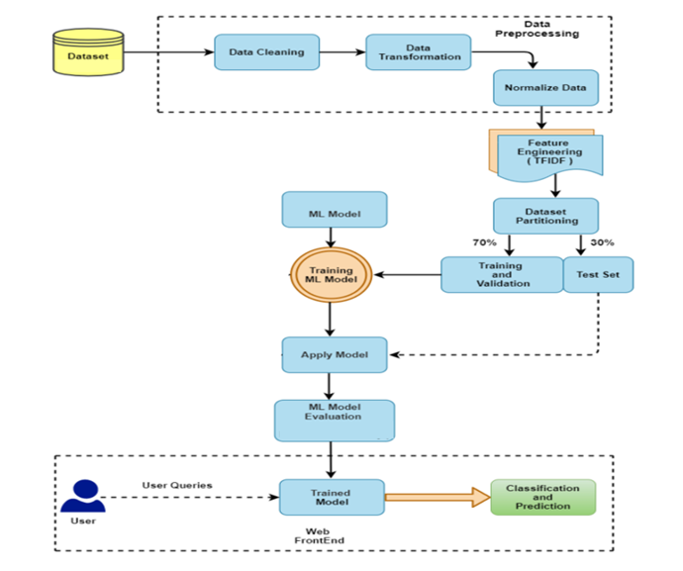

**Fig1:** Flow of the project

**3. Implementation:**

**1. Support Vector Classification (SVC):**

Support Vector Classification (SVC) is a powerful supervised learning algorithm primarily used for classification tasks. It works by finding the hyperplane that best separates different classes in the feature space while maximizing the margin between them. SVC is particularly effective in high-dimensional spaces and when the number of features exceeds the number of samples. It relies on support vectors, which are the data points closest to the decision boundary. SVC can handle both linear and non-linear classification through the use of different kernel functions such as linear, polynomial, and radial basis function (RBF). However, SVC's performance can be sensitive to the choice of parameters and the scaling of the input data.

**2. Random Forest Classifier:**

Random Forest is a versatile ensemble learning technique used for classification and regression tasks. It constructs numerous decision trees during training, with each tree being trained on a random subset of the data and features. The final output is determined by aggregating the predictions of all individual trees, either through voting for classification or averaging for regression. This approach helps reduce overfitting and enhances model generalization. Random Forest is suitable for large datasets with high-dimensional features, and its robustness to noise and missing values makes it popular in various machine learning applications. Additionally, its ease of implementation and interpretability contribute to its widespread adoption.

**3. Extra Trees Classifier:**

Extra Trees Classifier is an ensemble learning method for classification tasks, belonging to the family of decision tree algorithms. It works by constructing a multitude of decision trees during training and outputs the class that is the mode of the classes of the individual trees. What sets Extra Trees Classifier apart from other ensemble methods like Random Forest is that it selects features randomly for splitting nodes rather than searching for the best possible threshold. This randomization helps in reducing overfitting and computational cost while maintaining competitive performance. Additionally, Extra Trees Classifier introduces extra randomness by using random thresholds for each feature rather than searching for the best possible thresholds. This randomness during the construction of individual trees further enhances diversity within the ensemble. Extra Trees Classifier is often favored when computational resources are limited or when dealing with high-dimensional datasets due to its efficiency and robustness.

**4. Long Short-Term Memory (LSTM):**

Long Short-Term Memory (LSTM) is a type of recurrent neural network (RNN) architecture designed to overcome the vanishing gradient problem in traditional RNNs. Introduced by Hochreiter and Schmidhuber in 1997, LSTM networks have gained prominence for their ability to effectively capture long-term dependencies in sequential data, making them suitable for tasks such as speech recognition, language modeling, and time series prediction.

LSTMs employ a unique memory cell structure with input, output, and forget gates, allowing them to selectively retain or discard information over multiple time steps. The input gate regulates the flow of new information into the memory cell, while the forget gate controls the retention of previous information, and the output gate determines the information to be outputted. This architecture enables LSTMs to maintain long-term dependencies and mitigate the vanishing gradient problem, making them a powerful tool for modeling sequential data with complex temporal dynamics.

**4. Results and Discussion:**

The illustrations provided depict the sequential development stages of our project, showcasing the creation of a Flask framework.

**Homepage:** The main landing page features the logo design prominently, showcasing the unique branding of our website.



Fig2.Home page

**User home:** On this user home page, you'll find a detailed overview of our project

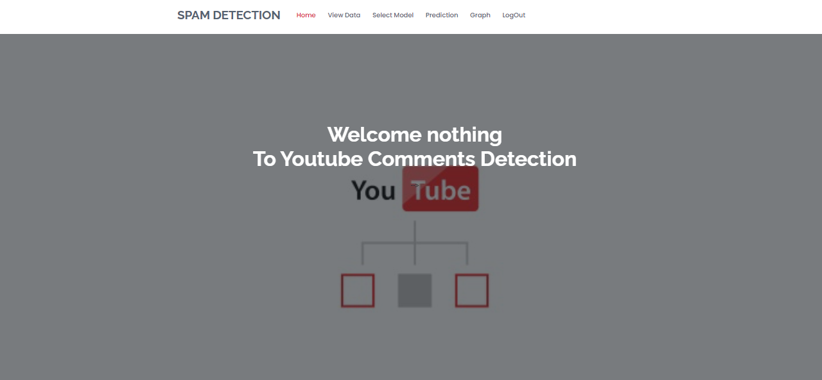

Fig3.User Home page

**Open the dataset:** Welcome to the page for dataset loading and view the data.

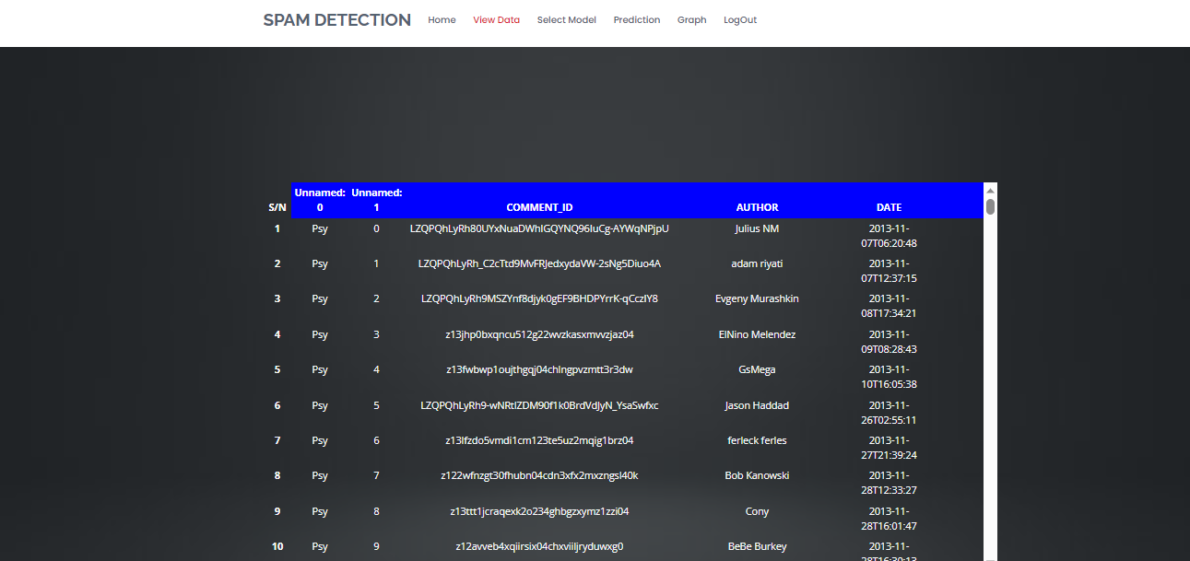

Fig4.View page

**Enhancement of Model Training and Evaluation:** This section enhances the procedures for model training, evaluation, and prediction.

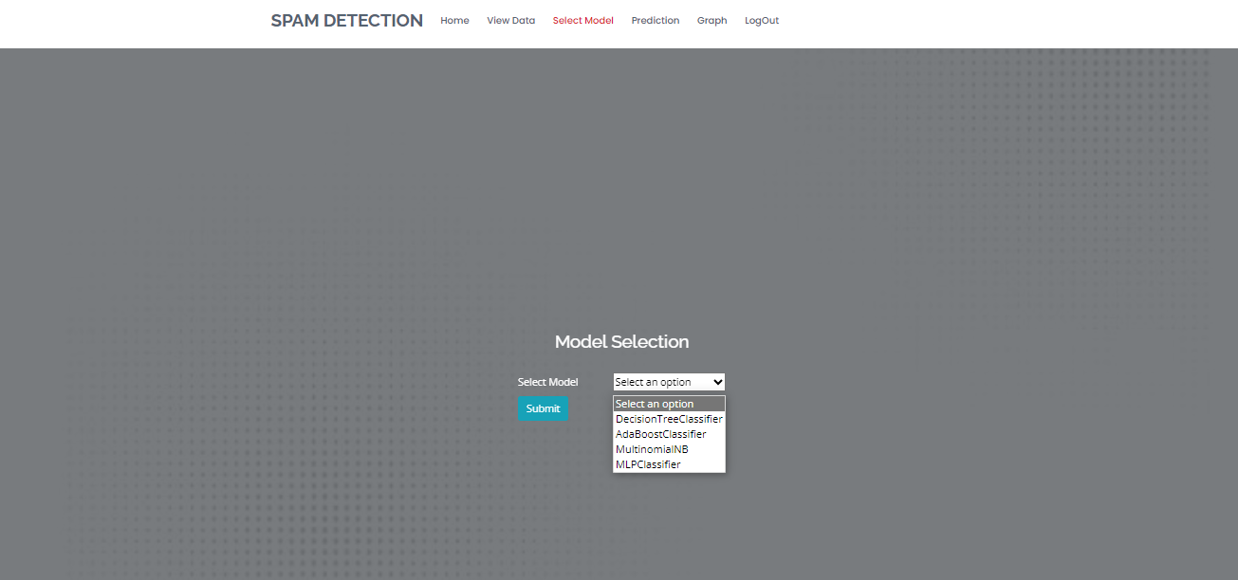

Fig5.model page

**To make a prediction:** The user will be required to input the values of the features in order to determine the output.

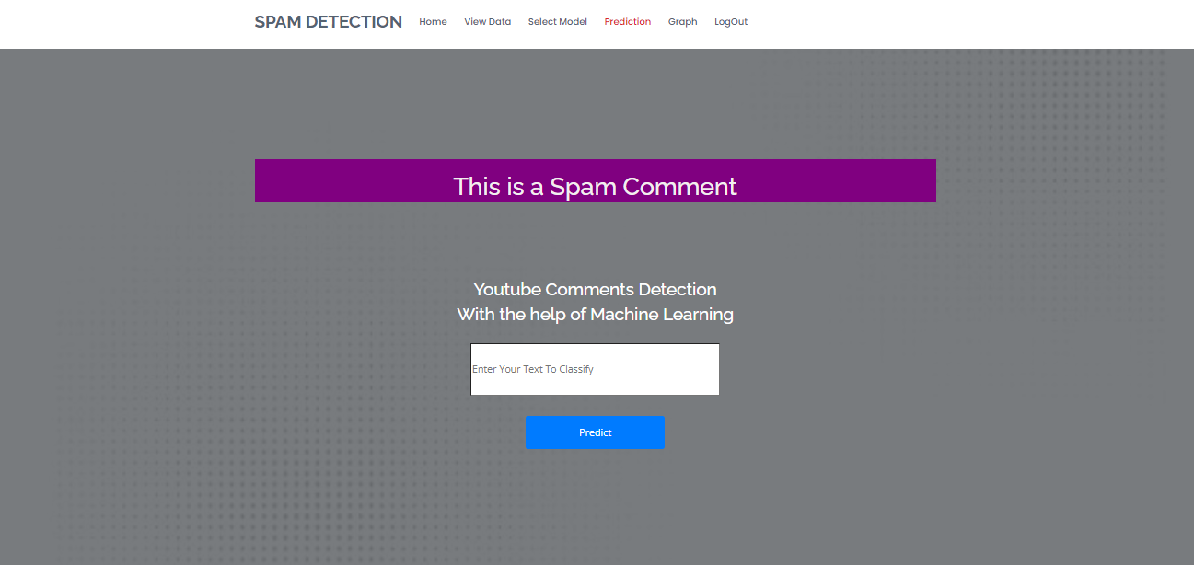

Fig6.prediction page

**5. Conclusion:**

In our study on YouTube spam detection using machine learning, we employed a diverse set of models, including SVM with the RBF kernel, Random Forest, LSTM (Long Short-Term Memory), and Extra Trees Classifier, to tackle the critical issue of identifying spam comments within YouTube's vast dataset of user comments. Our findings revealed that these models exhibited varying levels of accuracy, precision, and recall in distinguishing between genuine user comments and spam. While the CNN and LSTM models are demonstrated promising results by capturing temporal dependencies in text data, other models such as Random Forest and Extra Trees Classifier excelled in feature selection and ensemble-based classification. These outcomes underscore the complexity of spam detection in a dynamic online platform like YouTube. Our research contributes to enhancing user experience and content quality by automating the identification and removal of spam, ultimately making online communities safer and more engaging. Further refinements and advancements in machine learning techniques hold the potential for even more robust spam detection systems in the future.

**References:**

[1] Sah, U. K., & Parmar, N. (2017). An approach for Malicious Spam Detection in Email with comparison of different classifiers.

[2]Alberto, T. C., Lochter, J. V., & Almeida, T. A. (2015, December). Tubespam: Comment spam filtering on youtube. In Machine Learning and Applications (ICMLA), 2015 IEEE 14th International Conference on (pp. 138-143). IEEE.

[3] Alsaleh, M., Alarifi, A., Al-Quayed, F., & Al-Salman, A. (2016). Combating comment spam with machine learning approaches. Proceedings - 2015 IEEE 14th International Conference on Machine Learning and Applications, ICMLA 2015, 295–300. <https://doi.org/10.1109/ICMLA.2015.192>

[4] Scheltus, P., Dorner, V., & Lehner, F. (2013). Leave a Comment! An In-Depth Analysis of User Comments on YouTube. Wirtschaftsinformatik, 42.

[5] A. Kantchelian, J. Ma, L. Huang, S. Afroz, A. Joseph, J. D. Tygar, Robust detection of comment spam using entropy rate, in: Proceedings of the 5th ACM Workshop on Security and Artificial Intelligence, AISec ‘12, ACM, New York, NY, USA, 2012, pp. 59-70. doi:10.1145/2381896.2381907.

[6] S. Aiyar and N. P. Shetty, "N-gram assisted Youtube spam comment detection", Proc. Comput. Sci., vol. 132, pp. 174-182, Jan. 2018.

[7] A. Kantchelian, J. Ma, L. Huang, S. Afroz, A. Joseph and J. D. Tygar, "Robust detection of comment spam using entropy rate", Proc. 5th ACM Workshop Secur. Artif. Intell. (AISec), pp. 59-70, 2012.

[8] A. Madden, I. Ruthven and D. Mcmenemy, "A classification scheme for content analyses of Youtube video comments", J. Documentation, vol. 69, no. 5, pp. 693-714, Sep. 2013.

[9] A. Severyn, A. Moschitti, O. Uryupina, B. Plank and K. Filippova, "Opinion mining on Youtube", Proc. 52nd Annu. Meeting Assoc. Comput. Linguistics (Long Papers), vol. 1, pp. 1-10, 2014.

[10] M. Z. Asghar, S. Ahmad, A. Marwat and F. M. Kundi, "Sentiment analysis on Youtube: A brief survey", arXiv:1511.09142, 2015, [online] Available: http://arxiv.org/abs/1511.09142.